**InfoNet Raw Data Export Documentation**

**Run/Troubleshoot**

The script is set up to run every weekend at XXX on T448-DT308. – Still waiting on SSO to provide a service account to set this up to run

**What this script does:**

* Batch file (32/64) runs Raw_InfoNet_Export.rb using Innovyze IExchange and DeleteGDBs.py with python.
  + DeleteGDBs.py archives the existing XXX_InfoNet_Export.gdb to a GDB with the current day’s date in all folders with active exports.
  + Raw_InfoNet_Export.rb performs a “raw” export out of InfoNet (see All Configuration Files notes below)
    - All tables are exported with all the associated fields (with exceptions noted below)
    - **This is not a dynamic script. The configuration files will need to be replicated if any updates to InfoNet are performed to account for new fields/changes**

**Possible Issues:**

* Permissions to run .cmd files from G:/ is required
* Incorrect 32/64 file chosen
* Incorrect link to python location on C:/. This can be checked/verified by opening the appropriate .cmd file and looking at the python reference (circled below).

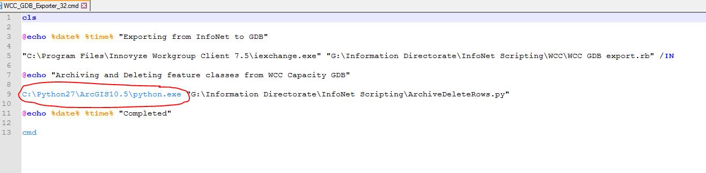

**Contents of ‘G:\Information Directorate\InfoNet Scripting\InfoNet Exports for GIS FME Transform’**

**1_Scripting**

**All Configuration Files –** This folder contains the InfoNet configuration files required for export. They are created using the auto-map function in the Open Data Exporter in InfoNet with a few alterations.

* All_DRN.cfg – Stormwater and Wastewater export configuration
  + Deleted unnecessary export field options that caused initial errors ‘unrecognized field names manhole.id, meter.node_id, etc…’. These were unnecessary fields and were deleted from the following table configurations:
    - Manholerepair
    - Manholesurvey
    - Metermaintenance
    - Metertest
  + The following tables are not exported due to version/ArcGIS errors that could not be fixed:
    - Approvallevel
    - Connectionpipenamegroup
    - Material
    - Nodenamegroup
    - Pipenamegroup
    - Order
    - Pipeclean
    - Resource
* All_PW.cfg -- Potable water export configuration
  + The following tables are not exported due to version/ArcGIS errors that could not be fixed:
    - Approvallevel
    - Material
    - Nodenamegroup
    - Pipenamegroup
    - Order
    - Resource

**Archive –** This folder contains old versions of scripts and random files.

**DW_Export –** This folder is a placeholder for if csv’s are a required export for Data Warehouse. (Should be covered by an FME transform)

**Errorlogs –** This folder contains any error logs that are created by InfoNet during the export. If an error occurs on the command line window that causes the script to fail, check this folder first for any potential errors.

**All_Exporter_32.cmd** – This file runs the exporter on 32 bit machines

**All_Exporter_64.cmd** – This file runs the exporter on 64 bit machines

* Both of these batch files run the python script that manages the GDB’s and the ruby script that InfoNet uses for the export explained below:

**DeleteGDBs.py –** This python script archives the older copy of the GDB by adding the date to the end of the filename. A new GDB with the “live” filename is then exported with the ruby script.

**Raw_InfoNet_Export.rb –** This ruby script exports a GDB with the raw data from InfoNet. See script for further explanation and documentation.

**All, SWDC, GWRC, HCC, PCC, UHCC, WCC**

These are the output folders that the exported GDBs are stored in. *Be sure to clear out old GDBs when they are no longer useful.*